Date: _____________________
Student Name: ___ _______________
Safe | - Stays in assigned area  - Keeps hands, feet and objects to self  - Walks with a purpose | 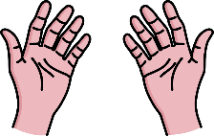
Respectful | - Uses appropriate tone, volume and language  - Listens to others and talks in turn | 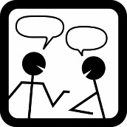
Responsible | - Brings necessary materials and personal items  - Participates in classroom activities and assignments
Daily Behavior Report Card
Activities or Time:
Safe
Respectful
Responsible

My Daily Goal (Check-In) | Things I Did Well (Check-Out) | Things I Need to Work On (Check-Out)
Adapted from Riley-Tillman, Chafouleas, & Briesch (2007), Vannest, Burke & Adiguzel (2006), Vannest, Soares, Adiguzel, e-DBRC (2006), Crone, Horner, & Hawken, (2004).

